Topic Modelling of McDonald's Store Reviews
LDA-Based Analysis of Customer Feedback Themes

1.0 Introduction
McDonald's operates thousands of stores worldwide, and customers leave a constant stream of online reviews describing their experience at each visit. These reviews are a direct, unfiltered source of feedback covering everything from food quality and order accuracy to staff behaviour and store cleanliness. Read individually, they are useful anecdotes; read at scale, they are a dataset that can reveal exactly where the customer experience is breaking down and where it is working well.
The practical challenge is volume. With tens of thousands of reviews arriving across hundreds of locations, no team can read every review manually and expect to spot patterns reliably or consistently. Manual review is also prone to bias: a manager might notice the complaints that match their existing assumptions and miss emerging problems elsewhere. What is needed is a systematic way to summarise what customers are actually talking about, at scale, without losing the nuance in their own words.
This project addresses that need using Latent Dirichlet Allocation (LDA). This topic modelling technique scans a large collection of text. It automatically groups it into a set number of underlying themes, based on which words tend to appear together across documents. Applied to McDonald's store reviews, LDA turns 33,396 unstructured reviews into a small set of interpretable themes, each backed by the specific words and reviews that define it.
The goal of this report is threefold: first, to identify the main themes customers discuss, whether about speed, food, staff, or store conditions; second, to separate which of those themes represent genuine complaints versus positive experiences, using star ratings as an independent check on the model's output; and third, to translate those findings into a short set of concrete actions McDonald's management can act on. The full methodology, findings, and recommendations follow below, with the complete analysis, code, and visualisations available in the accompanying Jupyter notebook.

2. Methodology
The dataset contains 33,396 McDonald's customer reviews across 40 US store locations, including star ratings, review text, store address, and review date. Text was cleaned in five steps: lowercasing, punctuation/number removal, tokenisation, stop-word removal (including the brand name itself), and lemmatisation with part-of-speech tagging. After cleaning, 32,874 reviews with usable text remained.
A Latent Dirichlet Allocation (LDA) model was trained on the cleaned corpus using a bag-of-words representation, with the vocabulary filtered to remove words appearing in fewer than 5 reviews or more than 50% of reviews. The number of topics was chosen by scanning topic coherence (cᵥ) scores from k=2 to k=10, then validating candidate values qualitatively by reading each topic's top words against the business question. Coherence alone favoured very low k (2–4), which produced uninformative topics; k=7 was selected as the smallest model where every topic was both internally coherent and clearly distinct. Each review was then assigned a dominant topic, and topics were cross-checked against star ratings information the model never saw during training to validate and interpret them.

3. Findings
The seven topics split cleanly along sentiment lines when checked against average star rating, despite the model having no access to ratings during training. This agreement confirms the topics reflect genuine patterns in customer feedback rather than noise.
Topic | Avg. rating | Type | Share of reviews
Rude Staff & Poor Customer Service | 1.54 | Complaint | ~1%
Drive-Thru & Wait Times | 2.27 | Complaint | ~4%
Order Accuracy (Wrong/Missing Items) | 2.42 | Complaint | ~3%
Order Delays & Follow-Up | 2.58 | Complaint | ~51%
Food & Menu Items | 2.79 | Neutral/Mixed | ~4%
Cleanliness & Facility Complaints | 3.44 | Mixed | ~1%
Fast, Clean, Friendly Service | 4.18 | Positive | ~35%

Four topics represent complaints and sit below the dataset's overall average rating. Rude Staff & Poor Customer Service scores lowest (1.54) but is low-volume, pointing to specific stores or shifts rather than a company-wide problem. Order Delays & Follow-Up is the largest topic overall (about half of all reviews), covering slow service and poor handling once something goes wrong — the single highest-impact theme by volume. Drive-Thru & Wait Times and Order Accuracy point to concrete operational failures: mismatched posted hours, unexpected closures, and missing or incorrect items, especially from mobile and kiosk orders.
Two topics represent positive experiences. Fast, Clean, Friendly Service (4.18 avg rating) is the second-largest topic and the clearest positive signal, with customers consistently pairing speed, cleanliness, and staff friendliness. Cleanliness & Facility Complaints shows a mixed rating spread, meaning cleanliness is used both to praise well-run locations and to criticise poorly maintained ones — indicating inconsistency across stores rather than a uniform problem.
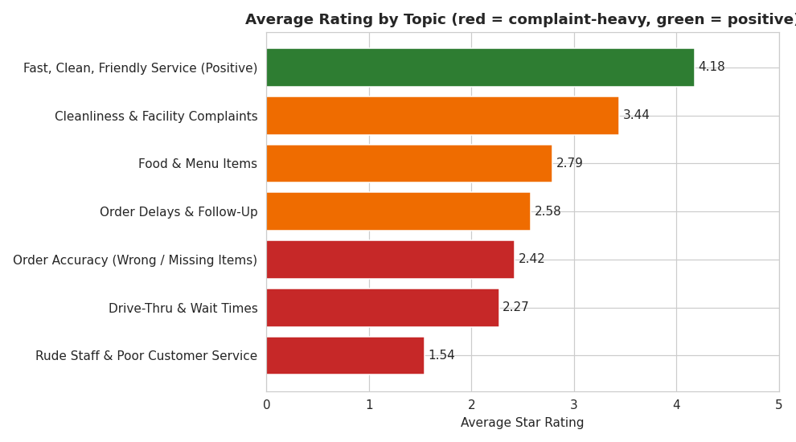
Figure: Average customer rating by topic, confirming the complaint/positive split.

4. Business Recommendations
- Fix order accuracy in mobile and kiosk ordering: require a visible order-check step at pickup, with a printed checklist matching the digital order.
- Standardise drive-thru hours and staffing: audit posted hours against real staffing schedules, and push real-time closure alerts to Maps and the app.
- Reduce order delays and improve complaint recovery: train shift managers on a standard recovery script (acknowledge, fix, follow up) — this addresses the single largest topic by review volume.
- Target customer service retraining at specific low-performing locations: the rudeness topic is severe but low-volume, so focus intervention on the stores driving it rather than a blanket campaign.
- Enforce a consistent cleanliness standard: introduce a scheduled cleaning checklist (hourly tables, bi-hourly restrooms) and audit compliance, since some stores already meet a high bar while others do not.

